LAB-6
6.1) Insertion at start.
CODE:
#include <stdio.h>
#include <stdlib.h>

struct Node {
int data;
struct Node* prev;
struct Node* next;
};

void insertAtStart(struct Node** head, int newData) {
struct Node* newNode = (struct Node*)malloc(sizeof(struct Node));
newNode->data = newData;
newNode->next = (*head);
newNode->prev = NULL;

if ((*head) != NULL) {
(*head)->prev = newNode;
}
(*head) = newNode;
}

void display(struct Node* node) {
printf("NULL <- ");
while (node != NULL) {
printf("[%d]", node->data);
if (node->next != NULL) {
printf(" <-> ");
}
node = node->next;
}
printf(" -> NULL\n");
}

int main() {
struct Node* head = NULL;

insertAtStart(&head, 30);
insertAtStart(&head, 20);
insertAtStart(&head, 10);

printf("Before: ");
display(head);

insertAtStart(&head, 5);

printf("After: ");
display(head);

return 0;
}
EXECUTION:
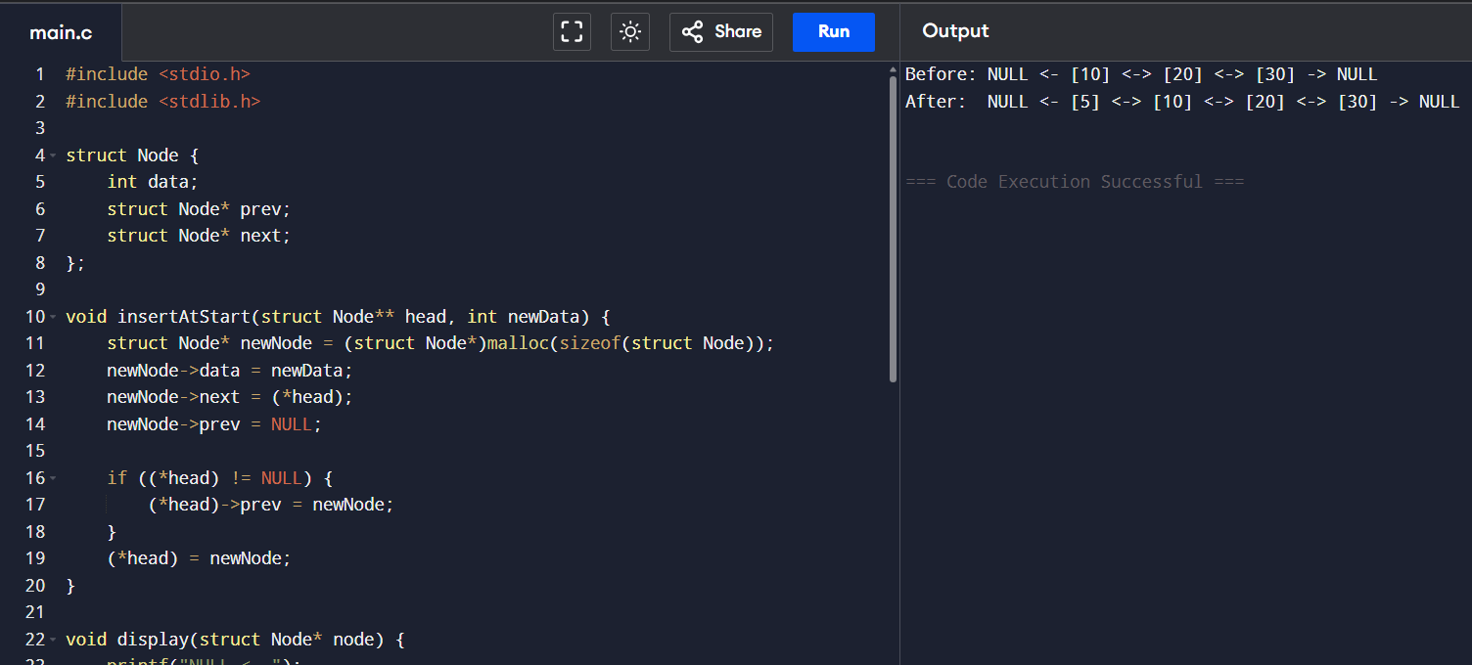

6.2) Insertion at end.
CODE:
#include <stdio.h>
#include <stdlib.h>

struct Node {
int data;
struct Node* prev;
struct Node* next;
};

void insertAtEnd(struct Node** head, int newData) {
struct Node* newNode = (struct Node*)malloc(sizeof(struct Node));
struct Node* last = *head;
newNode->data = newData;
newNode->next = NULL;

if (*head == NULL) {
newNode->prev = NULL;
*head = newNode;
return;
}

while (last->next != NULL) {
last = last->next;
}

last->next = newNode;
newNode->prev = last;
}

void display(struct Node* node) {
printf("NULL <- ");
while (node != NULL) {
printf("[%d]", node->data);
if (node->next != NULL) {
printf(" <-> ");
}
node = node->next;
}
printf(" -> NULL\n");
}

int main() {
struct Node* head = NULL;

insertAtEnd(&head, 10);
insertAtEnd(&head, 20);

printf("Before: ");
display(head);

insertAtEnd(&head, 30);

printf("After: ");
display(head);

return 0;
}
EXECUTION:
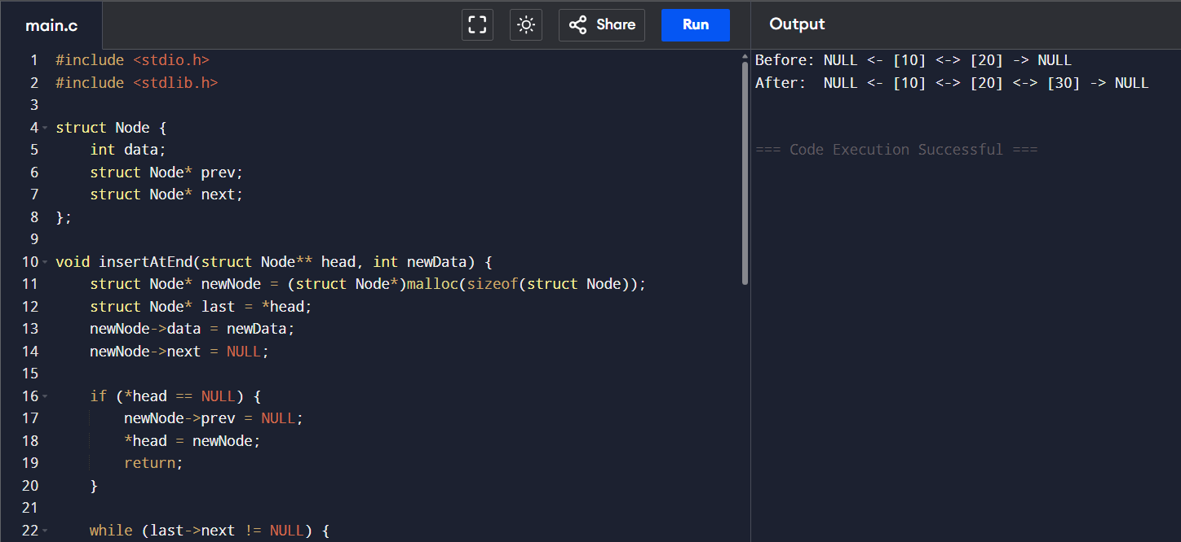

6.3) Insertion at given position.
CODE:
#include <stdio.h>
#include <stdlib.h>

struct Node {
int data;
struct Node* prev;
struct Node* next;
};

void insertAtEnd(struct Node** head, int newData) {
struct Node* newNode = (struct Node*)malloc(sizeof(struct Node));
struct Node* last = *head;
newNode->data = newData;
newNode->next = NULL;
if (*head == NULL) {
newNode->prev = NULL;
*head = newNode;
return;
}
while (last->next != NULL) last = last->next;
last->next = newNode;
newNode->prev = last;
}

void insertAtPosition(struct Node** head, int data, int pos) {
struct Node* newNode = (struct Node*)malloc(sizeof(struct Node));
newNode->data = data;

if (pos == 1) {
newNode->next = *head;
newNode->prev = NULL;
if (*head != NULL) (*head)->prev = newNode;
*head = newNode;
return;
}

struct Node* temp = *head;
for (int i = 1; temp != NULL && i < pos - 1; i++) {
temp = temp->next;
}

if (temp == NULL) return;

newNode->next = temp->next;
newNode->prev = temp;
if (temp->next != NULL) {
temp->next->prev = newNode;
}
temp->next = newNode;
}

void display(struct Node* node) {
printf("NULL <- ");
while (node != NULL) {
printf("[%d]", node->data);
if (node->next != NULL) printf(" <-> ");
node = node->next;
}
printf(" -> NULL\n");
}

int main() {
struct Node* head = NULL;

insertAtEnd(&head, 10);
insertAtEnd(&head, 20);
insertAtEnd(&head, 40);

printf("Before: ");
display(head);

insertAtPosition(&head, 30, 3);

printf("After: ");
display(head);

return 0;
}
EXECUTION:
